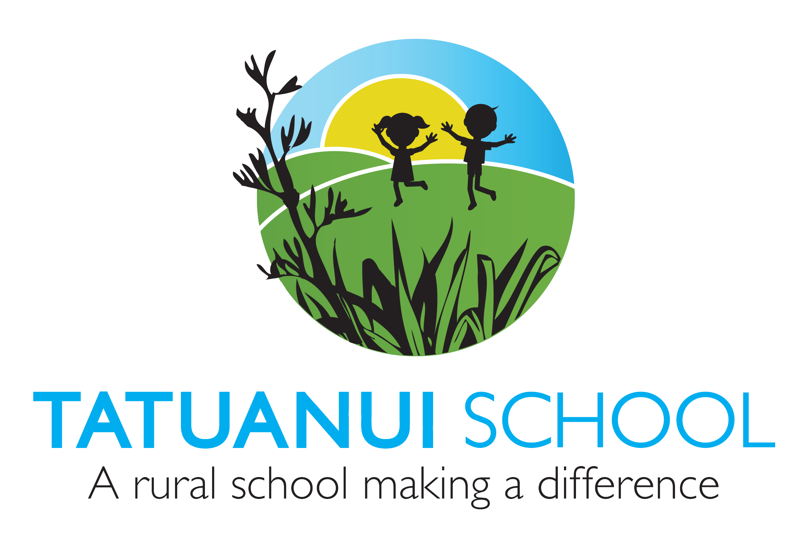
Cultural Diversity, Maori Dimension & Inclusion
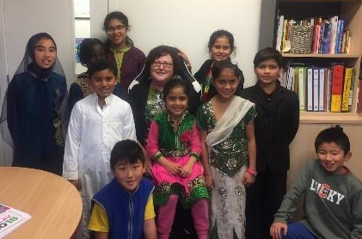
Cultural Diversity:
We value the cultural diversity of our community.
We have many different ethnic groups from around the world including our Maori and New Zealand Pakeha children. Within two to three years learners are expected to become proficient fluent users of both languages (1st language and English).
Our programmes show an awareness and respect of the different cultures within the school. We support, liaise and give guidance from within the school community to build relationships with families in supporting them to embrace the school ethos. We promote understanding of cultures, customs and languages through teaching focuses that are culturally relevant and inclusive. Learning support is given to ESOL students and progress/achievement is tracked carefully throughout the school. Annually, we have a cultural sharing day.
Maori Dimension: All reasonable steps are taken to provide instruction in tikanga Maori (Maori Culture) and te reo Maori (Maori Language) for full-time students whose parents ask for it.

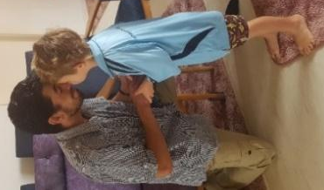
In 2020 as part of the Morrinsville Kahi Ako (Community of Learning) our focus is on ‘Developing cultural understanding to enhance cultural responsiveness.

Classroom teachers incorporate/integrate a Maori dimension within the classroom programme. Guidance for teachers is given through the curriculum Guidelines for Teaching and Learning Te Reo Maori in English Medium Schools: Years 1-13.
The school provides a focus on tikanga Maori (Maori customs, protocols and social values, and the link with the reo (language). As a Green Gold EnviroSchool one of the guiding principles is the principle of Māori Perspectives in which we respect and honour the status of tangata whenua in this land and the value of indigenous knowledge in enriching and guiding learning and action. In Term 2 we follow Matariki adopting a cross-curriculum focus for the duration of Matariki. In Term 1 of each alternate year the school undertakes a Marae overnight experience for the whole school community. In Term 3 each year the school participates in the Piako Cultural Performance festival.
Maori progress and achievement is tracked school wide throughout the school year and reported regularly to the Board and parents. Goals, through the strategic and annual plan are regularly monitored and reported on. Consultation with Maori parents is undertaken.
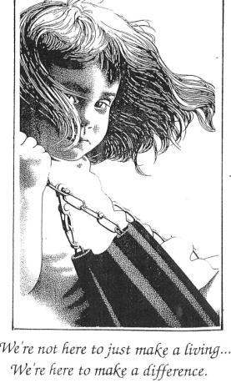
As per direction from the MOE through its policy document “Ka Hikitia” the school has set high expectations for Maori students. They are engaged in their learning, show pride in their identity, language and culture as Maori. Whanau is engaged in supporting their child’s learning. Our Maori student achievement is in keeping with school expectation.
Inclusion: Inclusion is defined as the process of increasing the presence, participation and achievement of all students in schools, with particular reference to those groups of students who are at risk of exclusion, marginalisation, or underachievement (Booth & Ainscow, 2002)
We are committed to providing a supportive, inclusive social and learning environment for every child to participate and achieve to their full potential. This means we –
- ‘Walk the talk’ - inclusive practice is visible in our school ethos
- Differentiate our programmes to meet teaching and learning needs
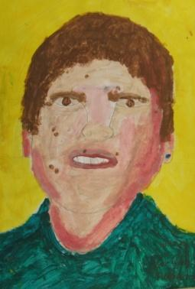
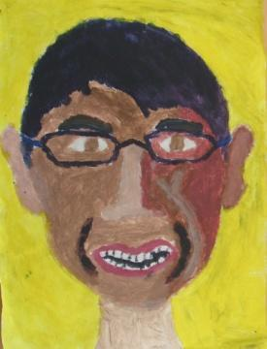
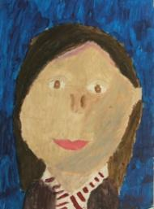
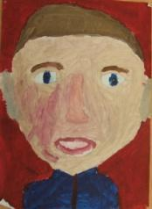
- Have strong positive working relationships with support agencies

