Annual Plan 2020
GOAL 1: TEACHING AND LEARNING
Focus on raising student achievement within an integrated curriculum with an emphasis on our priority learners and ESOL
TARGET: Curriculum Target:
Writing
- to lower the number of students who are ‘At Risk’ of not achieving / Progressing (Below expectation) from 19 students to 8
- 87% of our students will be achieving At/Above Tatuanui School expectation by the end of the year.
Reading
- to lower the number of Year 2 students who are ‘At Risk’ of not achieving / Progressing (Below expectation) from 11 students to 3.
- 87% of our students will be achieving At/Above Tatuanui School expectation by the end of the year.
Mathematics
- to move the 13 students who are ‘At Risk’ of not achieving / Progressing (Below expectation) to ‘At’ expectation.
- 87% of our students will be achieving At/Above by the end of the year.

TARGET: Non Curriculum Target:
- Through curriculum contexts increase the number of students able to demonstrate skills and strategies to overcome challenges

BASELINE DATA: Evidence of Whole School Improvement over Successive Years (2017 - 2019).
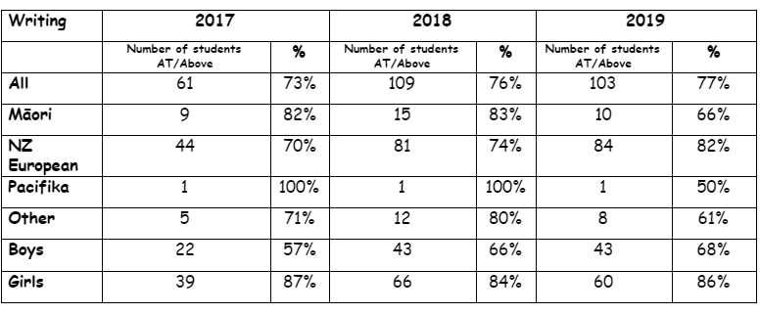
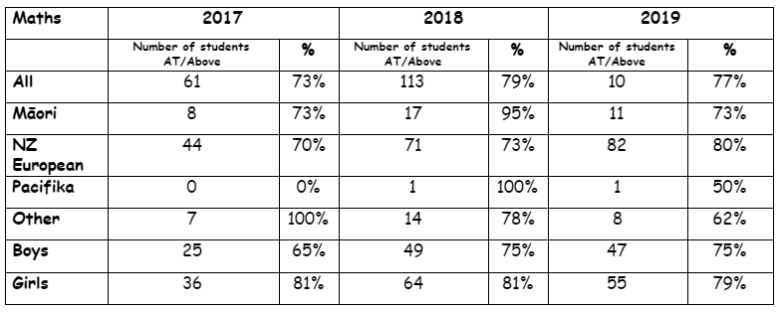
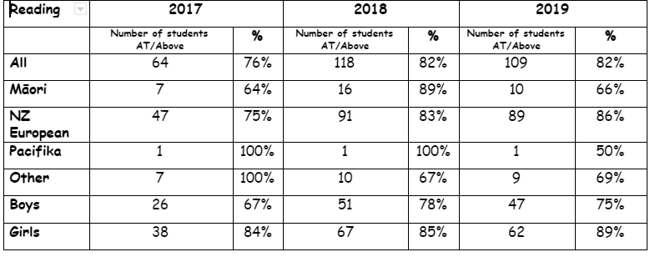

Writing:
2020 start up data: 70% of all students are At/Above expectation. 19/64 (30%) are Below expectation (11 are ‘At risk’ students, 8 are not achieving)

Reading:
2019 end of year data: 46% (11/24) Year 1 students were below Tatuanui School expectations.

Mathematics:
2019 end of year data: 17% (18/106, Yr 1 - 5) students were below Tatuanui School expectations.

KEY IMPROVEMENT STRATEGIES
What: Consider goal clarity & communication; strategic resourcing; PLD; routines that need changing; assessment practices; | Who: | When: What will we see? Indicators of Progress
- Inquiry: focus on using inquiry to build belief and effectiveness and make worthwhile changes in their teaching which will impact on student learning outcomes.  - WSL released weekly to work closely with teachers on their inquiry with targeted children - observations in class/discussion/monitoring progress/assessment  - Mentoring /Coaching for teachers in growing capability / capacity  - Use of CRT for teachers to work  - use of professional development staff meetings for dialogue/ moderation of student work samples  - Tracking by Principal to Board each meeting (monthly) of a selected target student. To follow through with informal ongoing regular checking in with class teachers on progress (1 student per class).  - Professional Reading focus on - mindset, efficacy, professional/open conversations - staff to critique for discussion at PLD meetings.  - Learning Assistant timetables (funding allocated) to work specifically with student needs.  - ESOL documentation is completed and Learning Assistant is timetabled to work with designated children  - Liaise with the SENcO to ensure ‘At Risk’ children are on the register and support has been applied for/followed up with outside agencies.  - Appraisals are linked to target students progress’  - External Professional Development targeted toward school goals  - Whanau engagement with the school  - Liaise with Maori Stakeholders  - Formal/informal Iwi conversations with Kaumatua and Whanau | WSL (CoL)  Leadership Team  SENcO  Teachers | By the end of term one, leaders will …...  - have seen / heard evidence that all teachers are actively engaged in (and can articulate) their inquiry - changes to practice, collaboration, student progress of target children  - ensured that all diagnostic assessments / have been completed as per school requirements.  - see that beginning of year data has been assessed, inputted into the SMS and children with needs have been identified.  - See that planning and teaching is catering for the needs of the children.  - ensure Learning support is targeted,planned for, implemented and monitored for ‘At Risk’ children identified.  - review Learning Assistant timetables every 5 weeks and ensure best use of resource/time is allocated to targeted needs.  - Have seen evidence of outside agencies working with teachers in support of identified children.  - see evidence of children identified that have made measureable progress.  - see consistently across the school setting and articulating goals by students of what they are learning to do and how they will know when they have achieved it.  - hear the language and see the behaviours of a growth mindset in children and teachers  - have completed a parent education evening in Mathematics (Prime Maths) to assist parents/caregivers understand and support their child’s learning.  - ensure the GATE register is completed - and planning for extension/enrichment is catered for.  - Ensure teachers know that appraisals will be linked to target student progress - evidence will identify specific teaching actions to address underachievement.  - Professional Development Log is kept by the Principal of courses/workshops/conferences attended by the whole staff and teachers individually for the year.  - CoL participation by teachers re Challenge C - Developing Cultural understanding to enhance cultural responsiveness  - Programmes include te reo Maori, classes have learnt the school karakia, pepeha, Treaty of Waitangi, Local History  - teachers have learnt and are teaching classes the CoL Waiata  - A google doc has been established to document any conversations with our Maori community and Kaumatua.
Monitoring How are we going –
As part of the weekly Leadership team meetings on the agenda will be a discussion of the ongoing monitoring, progress and achievement of target children, Learning Support Programmes, Inquiry, support/mentoring and or coaching of staff.
Monthly reporting to the Board by the Principal on a target child from each class to show work being done/progress being made
Regular meetings with DP/WSL (Robyn Hampton) with teachers to monitor progress and identify gaps/needs in classrooms
Review of LEA’s programmes every 5 weeks by SENcO/Principal
Monitoring of children on RTLB/Supplementary Learning Programme each term or at the conclusion of programme
Resourcing How much money and time is needed? Who will help us?
Funding for(Budgeted ): Teacher/LSA professional development, travel, Leadership meetings (weekly - 3 hours), WSL role funded by MOE (CoL) and time allowance - 1 day a fortnight.
SENcO - Management unit for responsibility - liaising with RTLB and other services

GOAL 2 SCHOOL CULTURE
Embrace and Embed our Mission Statement: A Rural School Making a Difference – Reaching our full potential as empowered 21st Century Learners - Vision, Values, Hauora, Enviroschools Kaupapa
Non Curriculum Target: Resilience ~ Learning to be Resilient
- To increase the number/percentage of children who are able to demonstrate skills & strategies to overcome challenges.
KEY IMPROVEMENT STRATEGIES
What | Who | When Indicators of Progress
Focus on Resilience as a non curricular target through a curriculum context.  School Leadership group established to meet weekly with the Principal.  One School rule - Make Sensible choices  Haurora - Health & Wellbeing - caring for all learners (socially, physically, environmentally, intellectually, spiritually and emotionally).  EnviroSchools kaupapa remains positive and we sustain our GreenGold status. | Teachers  &  students  Principal and a selected group of Yr 5-6 students  Students  &  Teachers  Teachers  Teachers  Teachers  Teachers  Principal  Principal  &  Teachers  Lead Teacher  Teachers  Board  Parents & Caregivers | - Context of Swimming will be reported to the Board using indicators; Developing (Teacher directed), Accomplished (with teacher guidance), Advanced ( without teacher guidance)  - Anecdotal evidence in relation to efforts in other curriculum areas to be noted for target children  - Google doc of minutes of the group meetings to be reported to the Board monthly. Student statement as part of the Principals report.  - Evidence of actions of the School Leadership group - e.g. representing the school speaking to ERO, Air NZ representatives, Environment Waikato, Local Council.  - Observations in and around the school particularly at break times  - Changes of behaviour of some specific students with behavioural challenges make positive changes to display the actions of the ‘Tatuanui child’. Teacher aide targeted support for behaviour will diminish with the goal of it being to be withdrawn  - School wide completion of the KOS (Keeping Ourselves Safe) programme Term 1 2020  - PLD for Senior teachers in IYP (Incredible Years Programme  - class programmes are differentiated to meet learner needs. Evidence in planning, monitoring and assessment  - Take and utalise timetabled CRT as per contract  - Actively seek to improve transition for students both from ECE and Intermediate.  - Track attendance of students. Ensure absences are followed up and report at the end of each term to the Board of Trustees.  - through email/face to face (informal/formal) meetings maintain a positive relationship with parents/caregivers to ensure we know the ‘whole child’ and can support appropriately.  - Teachers teach and maintain healthy practices in classrooms - washing hands, sunsafe, healthy eating, regular physical fitness  - we caRe duties throughout the school daily  - Reduce, recycle, reuse practices are evident in and around the school  - EOTC activities are linked to the authenticity of being an enviroschool  - the Enviroschools facilitator is actively engaged with the school developing knowledge, understanding and practices of an enviroschool  - Wider community relationships are established, maintained and promoted to embed and sustain the ethos of environmental sustainability
Monitoring How are we going – Monitor through Huddle, PLD minutes, monthly reports from Principal to Board, timetabled use of external facilitator, reaccreditation of being:Sunsafe school, Healthy Eating School, GreenGold ENviroschool, ERO review, school self review, CoL review
Resourcing How much money and time is needed? Who will help us?
Funding - Ops Grant for - curriculum, LSA (Learning SUpport Assistant), RTLB, LSF, Principal & student leaders meet formally once a week for half an hour. Management unit for responsibility Maori/ENviroschools. Participation in the Enviroschools PLD programme as required by the lead teacher,

GOAL 3 INNOVATIVE LEARNING ENVIRONMENT
Provide a safe, up-to-date learning / teaching environment for students and teachers.
KEY IMPROVEMENT STRATEGIES
What | Who | Indicators of Progress/When
Health & Safety  Learning & Teaching Environment  Budget | Office Manager  Principal  Principal & Property Rep (BoT)  Principal, finance Officer & Finance BoT rep  (Finance subcommittee)  Principal | - staff are first aide accredited  - visitors, students late/leaving early sign in/out of the school  - a fire/lock down drill is undertaken each term  - The first aide book, accident register, is completed after each incident  - Students with high medical needs are clearly identified in the sick bay and duty teachers bag  - The asbestos management plan is shown to all workers on site on arrival  - Adequate cleaning supplies, emergency classroom kits are well stocked and checked regularly  - Building safety compliance Manual and checks are completed and documented monthly  - Provide furniture/equipment to enable teaching and learning to meet needs as required  - Provide teachers with curriculum & classroom budgets to adequately provide for budgeted resources/consumables  - liaise with teachers in the development of a concept design for a MLE that reflects Tatuanui School ethos -design signed off by the Ministry mid Term 1.  - liaise with project manager to ensure replacement of Building A reflects the requirements of the school - completion of project end 2020.  - budget reflects the requirements of the school to meet the needs of an effective teaching/learning environment  - monitor monthly spending in line with budget and report monthly to the Board
Monitoring How are we going – Regular progress meetings with Property sub committee, monthly compliance checks, Principal reporting to the BOard, Budget monitoring (xero) with subcommittee, asset register maintained (nb depreciation), accountants (de Loitte), auditor (Crowe Horwath) re annual accounts.
Resourcing How much money and time is needed? Who will help us? Operational funding budgeted for 2020, asset register, MOE - project Manager (Lawrence Joseph), & property Senior Advisor (Alana Plasmeyer),

