FOCUS 1  TEACHING AND LEARNING  Raising student achievement within an integrated curriculum with an emphasis on our priority learners and ESOL.  Develop learners (students, teachers &/or caregivers) who:  *actively participate in the learning process  (Learner Agency)  *have a Growth Mindset  *experience success  * grow their capacity and capability  *participate & contribute respectfully,  collaboratively (cooperatively) & collegially (relationships)  Wider Community of Learners:  Participate as members of the Morrinsville Kāhui Ako in addressing the four levers of change  Challenge A: Teacher Efficacy  Challenge B: Student Agency  Challenge C: Family, Whanau &  Community Partnerships  Challenge D: Hauora (Health & Wellbeing) | 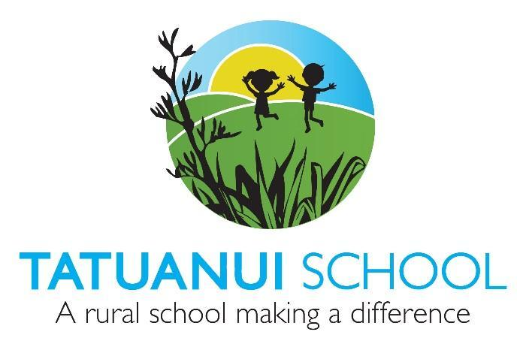  FOCUS 2  SCHOOL CULTURE  Embrace and Embed -  *Our Mission Statement:  ‘‘A Rural School Making a Difference’ Reaching our full potential as 21st Century Learners  *Our Vision that all learners will be: Self-motivated, Resilient, Problem Solvers, Communicators & Collaborators  * Our Values - we ‘caRe’: caring,attitude, respectful, responsible, enviro ‘kids’  * Hauora- by caring for the health and wellbeing of all learners (socially,physically, environmentally, intellectually, spiritually & emotionally)  *the positive ethos of the Enviroschools Kaupapa and maintain our Green-Gold Enviro School Status. | STRATEGIC PLAN  Overview  2020 - 2022  FOCUS 3  INNOVATIVE LEARNING ENVIRONMENT  Provide a safe, up-to-date learning & teaching environment for all learners  *Health & Safety is paramount in consideration of and for all learners through good practice, monitoring and self review.  *Provide a learning and teaching environment that is well resourced to effectively support educational opportunities for all learners.  *Effectively manage the Budget through forecasting, prioritising & spending.

